Algoritmi genetici: 1/0 Knapsack Problem

|  |  |  |  |  |  |  |  |  |  |
| --- | --- | --- | --- | --- | --- | --- | --- | --- | --- |
| ID Obj | A | B | C | D | E | F | G | H | Capacitate  Rucsac |
| Val | 10 | 12 | 5 | 14 | 9 | 7 | 15 | 10 |
| Weight | 7 | 9 | 2 | 10 | 10 | 6 | 12 | 12 | 30 |

Cum ar arata un cromozom?

Cromozomul va avea lugimea egala cu numarul obiectelor. Iar pe fiecare pozitie (gena), va fi valoarea 1 daca obiectul corespondent este selectat in multiemea de obiecte ce va fi pusa in rucsac, sau 0 altfel.

Ex:

|  |  |  |  |  |  |  |  |
| --- | --- | --- | --- | --- | --- | --- | --- |
| 1 | 0 | 1 | 0 | 0 | 1 | 1 | 0 |

Cromozomul de mai sus codifica solutia formata din obiectele: A,C,F,G;

Functai de fitness: Cum va fi ea definita/”croita”?

Spre exemplu: ce fitness ar tb sa aiba cromozomul de mai sus: Val(A)+Val(C)+Val(F)+Val(G)=37

Dar pt cromozomul

|  |  |  |  |  |  |  |  |
| --- | --- | --- | --- | --- | --- | --- | --- |
| 1 | 0 | 0 | 1 | 0 | 1 | 1 | 0 |

Ar fi Val(A)+Val(D)+Val(F)+Val(G)=46? NU! deoarece greutatile depasesc capacitatea rucsacului!

Revenim la intrebare: cum definim functia de fitness?

fie X=(x1,x2,...xn) - un cromozom

definim functia de fitness astfel :

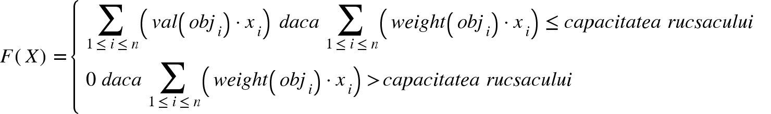

Populatie?

Un numar de indivizi/cromozomi existenti la un moment dat.

|  |  |  |  |  |  |  |  |  |
| --- | --- | --- | --- | --- | --- | --- | --- | --- |
| Populatie: | | | | | | | | Fitness |
| 1 | 1 | 0 | 0 | 1 | 0 | 0 | 0 | 31 |
| 1 | 1 | 1 | 0 | 1 | 0 | 0 | 1 | 0 |
| **0** | **0** | **1** | **1** | **0** | **1** | **1** | **0** | **41** |
| 0 | 1 | 0 | 0 | 0 | 1 | 0 | 0 | 19 |

Procesul de selectie:

* metoda ruletei:  
  Fiecare cromozom va avea o probabilitate de selecție calculata astfel  
  individul 1: 31/91=0.34066

individul 2: 0

individul 3: 41/91=0.45054

individul 4: 19/91=0.20880

Intervalele de selectie pt fiecare individ:

[0,0.34066);();[0.34066,0.79120);[0.79120,1)

s-a selectat cromozomul 3 (elistist)

u: 0.82654 -> s-a selectat cromozomul 4

u: 0.77516 -> s-a selectat cromozomul 3

u: 0.42359 -> s-a selectat cromozomul 3

Procesul de crossing over:

dintre cromozomii selectati: sa zicem ca cromozomii 3 si 4 sunt selectati pt crossing over:

cromozomul 3: *001*10110

cromozomul 4: *010*00100

generam aleator un punct de rupere: 3

obtinem 2 noi cromozomi:

*00100100*

*01010110*

In acest moment populatia arata astfel:

**00110110 (**cromozomul 3**)**

**00110110 (**cromozomul 3**)**

**00100100**

**01010110 (**cei 2 cromozomi obtinuti dupa recombinate 3&4**)**

Procesul de mutatie:

se parcurge fiecare gena a fiecarui cromozom, si pentru fiecare gena, exista o sansa minuscula (ex: <0.01) sa i se schimbe valoarea:  
Ex **00110110** devine **00100110**

**Populatia rezultata - care reprezinta o noua generatie:  
 00110110**

**00100110**

**00100100**

**01010110**